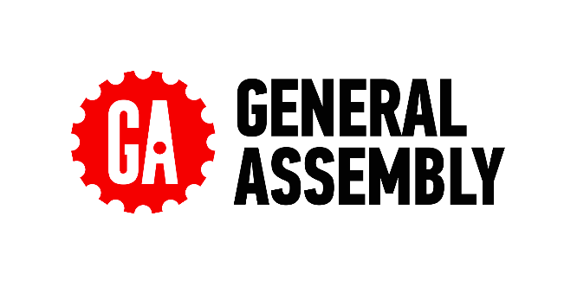**ReadMe Template Worksheet**

Your ReadMes are the key deliverable that engineers will want to see as part of your job search. Each engineering team will look at different aspects of your ReadMe and repo. Some will go into the code itself and explore. Others will just want to see the showcase code snippets in the main ReadMe. Some will read the full thing to understand your approach, others will skim to specific sections.

It’s crucial that you cover all the different sections below to ensure that you’ve got the information for all engineers that check these out.

We regularly have employer partners discuss the importance of the ReadMes in what they’re looking for and why they interview the grads that they do - so don’t underestimate the importance of writing strong ReadMes!

For any pair or group project, you cannot share a ReadMe. These must be written independently to ensure that the engineers reading this understands **your** specific experience and approach.

It’s a good idea to start your ReadMes during the planning stage as this is the best way to get ahead and save time when it comes to finalising your first draft post-project. As you plan each aspect of your project, note down what you intend to do with screenshots of your plan and anything else you think would be useful, then when you execute this part in your code, you can adjust this part of your ReadMe as needed depending on how your process changed, or if it went as planned then you can leave it as it is.

**Make a copy of this document for each project you use throughout the course and fill in each section. Keep your copy in your Outcomes folder, so the team is able to add feedback into your docs.**

Once the content has been finalised by the Outcomes team, you can then upload these onto your GitHub repository later.

**Things To Consider:**

* That there are **no spelling mistakes in your ReadMe** - if you see a spelling error highlighted below, edit this.
  + Some engineers will reject applicants if their ReadMes are full of mistakes. From their perspective, if your ReadMes are full of mistakes, what is your code like…
* That your **technologies are capitalised correctly** - i.e JavaScript, jQuery, MongoDB
* That your **formatting is consistent** throughout - headers, indentation, full stops in bullets etc
* Any **hyperlink included works**
* That you **include images throughout** - code snippets, pictures of your planning stage, screenshots of the final project.
  + These can be still screenshots or gifs
  + This breaks up the text in your ReadMe and helps to keep the reader engaged
* That your ReadMe **sounds like you** - see this as an opportunity to showcase who you are to the engineering community and prospective employers.
  + Think back to the Personal Brand session and how employers want to **get a sense of who you are**. The content you write should sound as if you’re talking through your experience.

**ReadMe Sections**

**Description**

**Instructions**

*Here, give a short description of the project. It can be a couple of sentences where you discuss the point in time during the course that you completed it, the topic of the project and potentially the tech stack.*

**Insert your Description here:**

**Dinspiration**

Project 3 was a full-stack MERN app that we built for all food lovers that in busy times would like to have something quick and healthy on their table when coming back home. An app that everyone could access wherever we are, bus, train or working in our office. Cooking would be a more creative and happier moment if we could share our ideas.

**Deployment link**

**Instructions**

*Here include the information on where the deployed project can be found. If login details are needed to access the full project, make sure you include them.*

*If you have not yet deployed your project, you can add this in later.*

**Insert your Deployment link here:**

Click the project link below to give it a try.

[**https://dinspiration.netlify.app**](https://dinspiration.netlify.app)

**Getting Started/Code Installation**

**Instructions**

*Explain how the reader accesses your code. Include a step by step approach.*

**Insert your Getting Started/Code Installation here:**

### **Backend**

1. clone repo Dinspiration-Backend
2. open Dinspiration-Backend in my code editor
3. cd into the root directory and run 'npm i' in the terminal to install the dependencies
4. run 'npm run seed' in the terminal to add the seed data for your demo
5. run 'npm run build' in the terminal to build the JavaScript in the dist folder
6. run 'npm run dev' in the terminal to run the program

### **Frontend**

1. clone repo Dinspiration-Frontend
2. open Dinspiration-Frontend in my code editor
3. cd into the root directory
4. run 'npm i' to install the dependencies
5. run 'npm run build' to build the JavaScript files in the dist
6. run 'npm run dev' to run the program
7. Preview the index.ts in the browser

**Timeframe & Working Team (Solo/Pair/Group)**

**Instructions**

*Share the timeframe given for the project and whether you worked independently, in a pair, or in a group.*

*If you worked in a pair or group, include the names of the people you collaborated with. As a bonus, you can also provide links to their GitHub repo.*

**Insert your Timeframe & Working Team here:**

**Project Members:**

* **Pamela Smith:** [**https://github.com/PamelaOnGit**](https://github.com/PamelaOnGit)
* **Jane Adojutelegan:** [**https://github.com/lumpyspayzprincess**](https://github.com/lumpyspayzprincess)
* **Shkendi Naqellari:** [**https://github.com/shkendi**](https://github.com/shkendi)

**Timeframe: 11 days.**

**Technologies Used**

**Instructions**

*List every technology you used to complete the project. This can be in one long list, or broken down into categories (Back End, Front End, Development Tools).*

**Insert your Technologies Used here:**

**Technologies used:**

* React.js
* Node.js
* Express
* MongoDB/Mongoose
* SASS
* Bulma
* Axios
* Nodemon
* HTTP-proxy-middleware
* Bcrypt
* JSON web token
* Git/GitHub

**Brief**

**Instructions**

*Include the brief set by your instructional team here. This sets the context of the project you were working towards and mimics briefs you will be set later in your future roles.*

*This can either be in bullets or in a paragraph.*

**Insert your Brief here:**

## **Technical Requirements**

* Work in a team, using git to code collaboratively
* Build a full-stack application by making your own backend and your own front-end
* Use an Express API to serve your data from a Mongo database
* Consume your API with a separate front-end built with React
* Be a complete product which most likely means multiple relationships and CRUD functionality for at least a couple of models
* Implement thoughtful user stories/wireframes that are significant enough to help you know which features are core MVP and which you can cut
* Have a visually impressive design to kick your portfolio up a notch and have something to wow future clients & employers. ALLOW time for this
* Be deployed online so it's publicly accessible
* Have automated tests for *at least* one RESTful resource on the back-end Improve your employability by demonstrating a good understanding of testing principles.

### **Necessary Deliverables**

* A working app hosted on the internet
* A link to your hosted working app in the URL section of your Github repo
* A git repository hosted on Github, with a link to your hosted project, and frequent commits dating back to the *very beginning* of the project
* A readme.md file with:
  + An embedded screenshot of the app
  + Explanations of the technologies used
  + A couple of paragraphs about the general approach you took
  + Installation instructions for any dependencies
  + Link to your user stories/wireframes – sketches of major views / interfaces in your application
  + Link to your pitch deck/presentation – documentation of your wireframes, user stories, and proposed architecture
  + Descriptions of any unsolved problems or major hurdles you had to overcome

**Planning**

**Instructions**

*The planning stage is important, as all projects in your future roles will have detailed plans before any coding happens. It is a great experience to share with potential engineer employers, as this reflects real engineering team practices.*

*Start by explaining the initial steps you took in the project.*

* ***Did you do any sketches****? If so, discuss this and include images.*
* ***Any wireframes of the front end and UI****? You did? Then explain this and include images.*
* ***Any ERDs****? Same here, explain and include images.*
* ***Use a project management tool to plan the sprint****? If so, talk through this - what tool did you use? How you allocated tickets/responsibilities, sprint timeline etc. Also include screenshots of this.*
* ***Any pseudocode****?*
* ***If it was a group or pair project*** *- Discuss who was designated which tasks. This is very important, as engineers want to understand who owned the different code elements when looking at a group project.*

*For each project, review the above bullets and discuss every step you took in the planning stage, including the relevant images.*

*Not every project will include the above, but it’s important to discuss any of the bullets that you did implement.*

**Insert your Planning here:**

We agreed on a food app; when we are busy with work, family and friends, meals can become a chore and we can end up eating the same things every day. We all liked the idea of an app that allows users to inspire one another with fun and interesting suggestions.

We agreed that Pam would take the lead on the user flow, Jane on the foods, and me on the recipes (which we called “inspirations”). We all contributed to the planning with ideas and logic and agreed that Jane would configure it using Figma. Planning was done mainly on the first day, added a few more details the day after, and then we jumped straight into the coding stage.

We used Figma to create a mock-up of how the app would function. We worked up a flow, as follows:

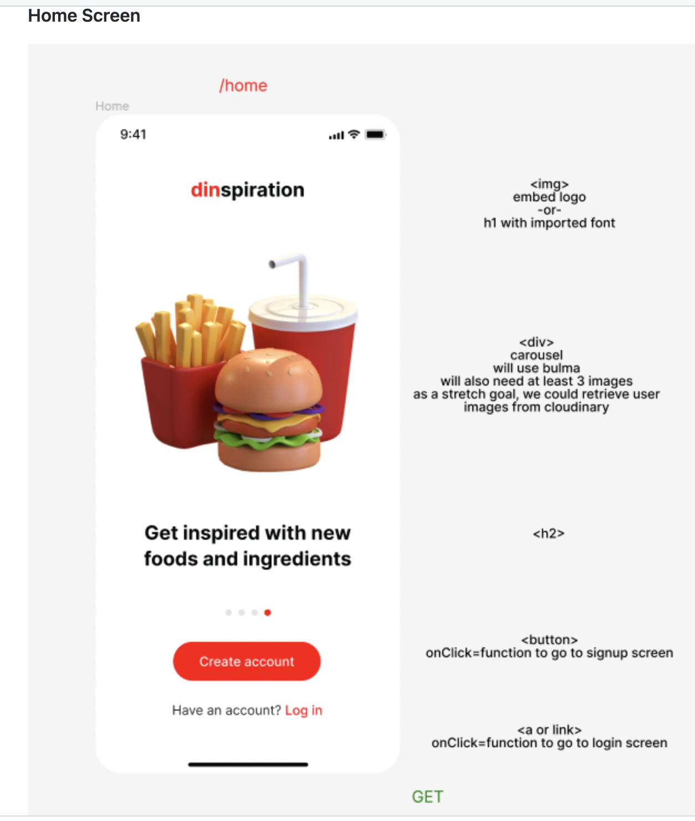

#### **Signup and Login**

Once logged in, the user is invited to provide some information about the sort of food they might want to try:

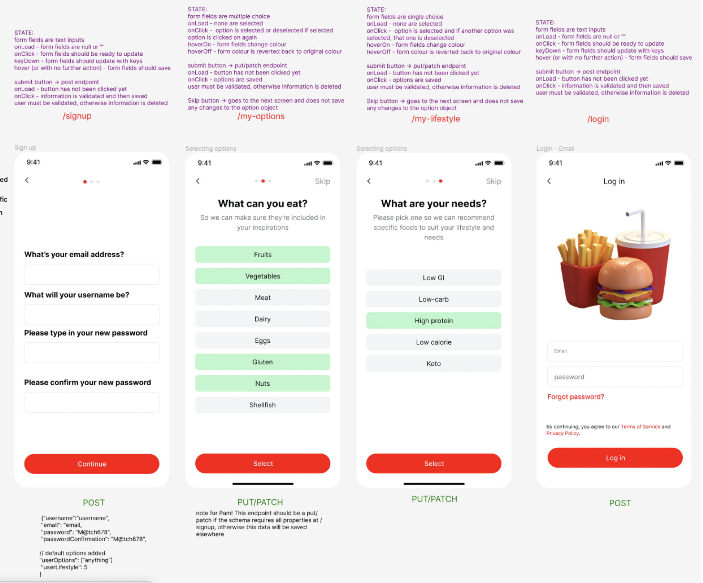

#### **My Foods, Food Screen and Recipes**

The user is then presented with a selection of slightly unusual ingredients to try out. Clicking on a particular food takes the user to a screen with more information about the chosen food and, below it, a selection of user-generated recipes and serving suggestions:

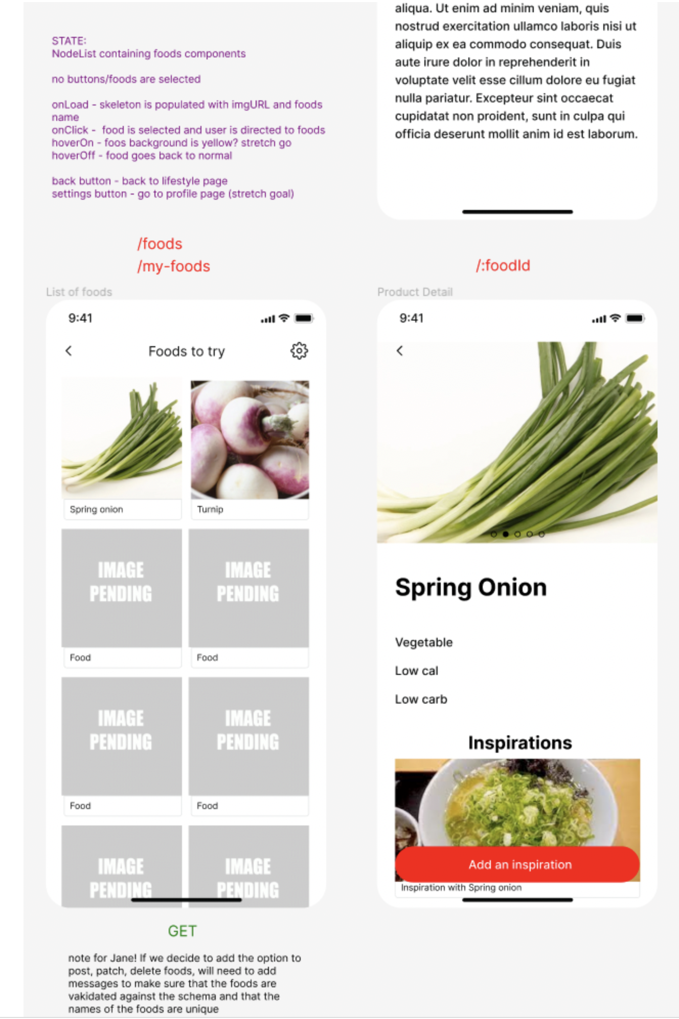

#### **Add Recipe**

The user can share their own recipe or serving suggestion, along with a photo of their creation.

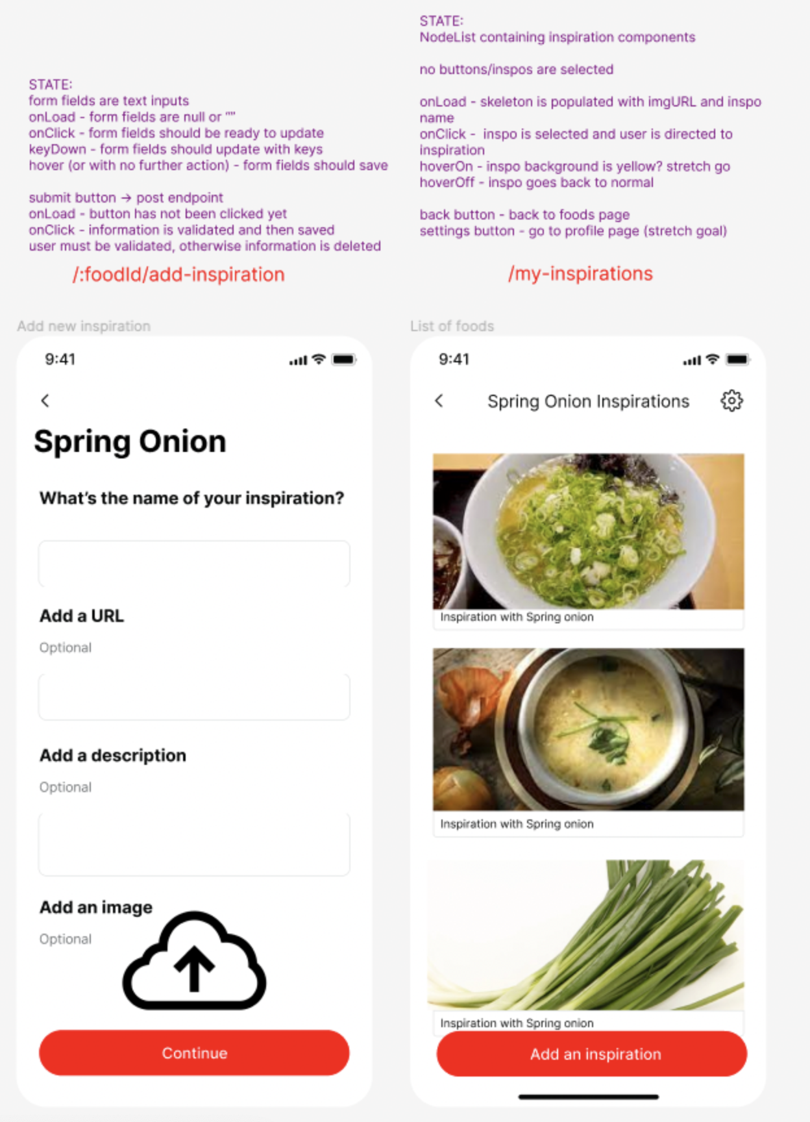

**Build/Code Process**

**Instructions**

*The Build/Code Process will be the longest section of your ReadMe and will be most insightful to the engineers that review them. This is where you will discuss the steps you took to code the project.*

*You want to see your ReadMes as a way to walk the engineers through your approach and problem solving from the start of the project through to the end.*

*You'll need to include a minimum of 3-4 code snippets, highlighting code you're particularly proud of and these code snippets will have descriptions on what you did, how and why to set the context of the snippet you include. These explanations are important for the engineers, as they will want to understand what you did and the reasoning behind the steps you took.*

*You don't need to document every single thing you coded, but walk them through the key sections of the project build.*

*For any group project, you will just focus on your contributions.*

*Some people will document the build/code process by discussing the key stages they worked on. Others will do a day by day guide. It’s entirely up to you how you structure this, as long as you discuss all the key things above.*

**Insert your Build/Code Process here:**

1. We set up a Jira project and divided the project into stages: planning and setup, backend-setup, backend development, frontend-setup, frontend development, and testing.
2. Pam set up the project called Dinspiration, dinspiration-backend and dinspiration-frontend, and we cloned it.
3. I set up two branches and called them Shkendis-Backend and Shkendis-Frontend and pushed all the code to the main repository every time I made changes. I started on the backend by creating a basic API with some dummy user data in a file inside the backend repo.

1- Inspiration schema

I created the InsirationSchema on the backend after working out what data we needed to pass through, how would a screen page connect to another, typeof and whether they were required or not.

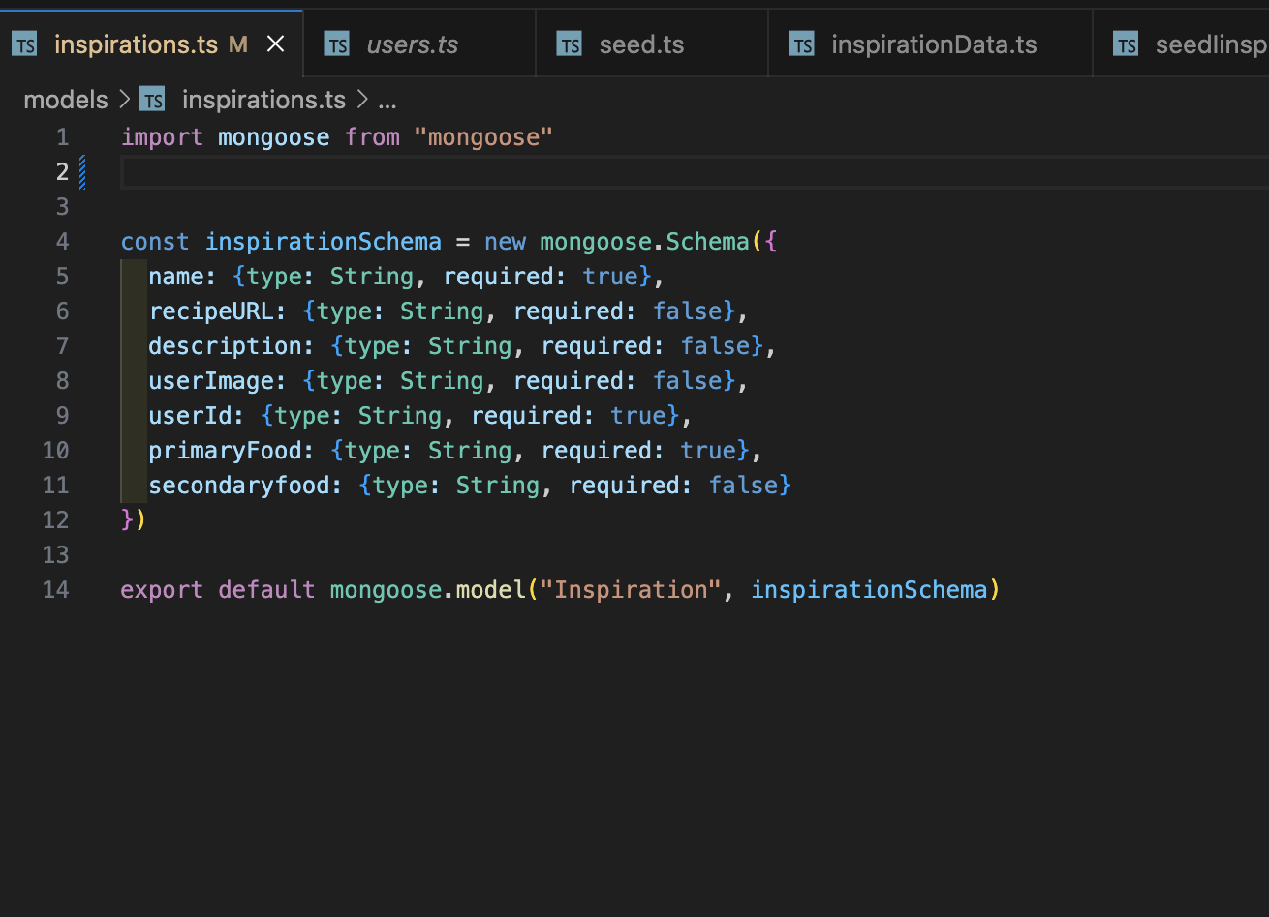

Based on the schema, I created the InspirationData file with some data to seed, so I created a db folder with a new file in it which I called inspirationData. Inside it, I created a variable called inspirationData and assigned it an array of inspirations objects based on the inspirationSchema which I had previously created in models folder.

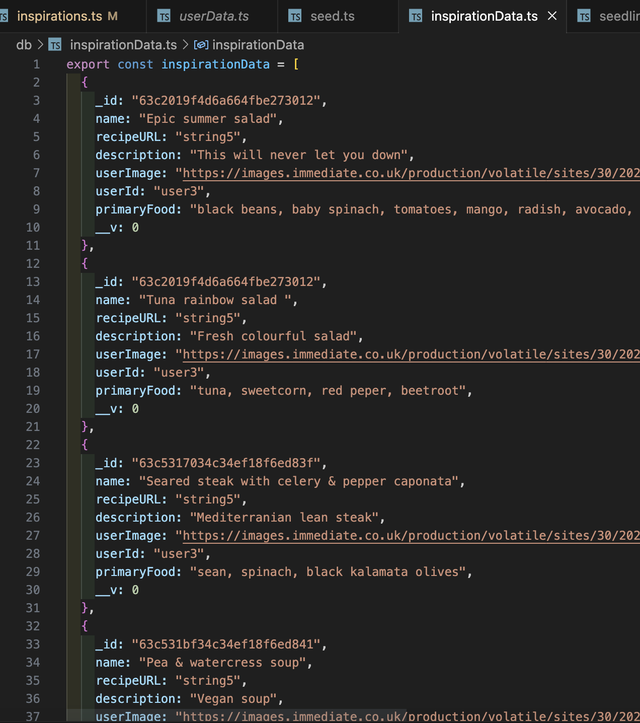

Here are the functions for making our requests, get, getById, post, put/patch and delete using json promises.

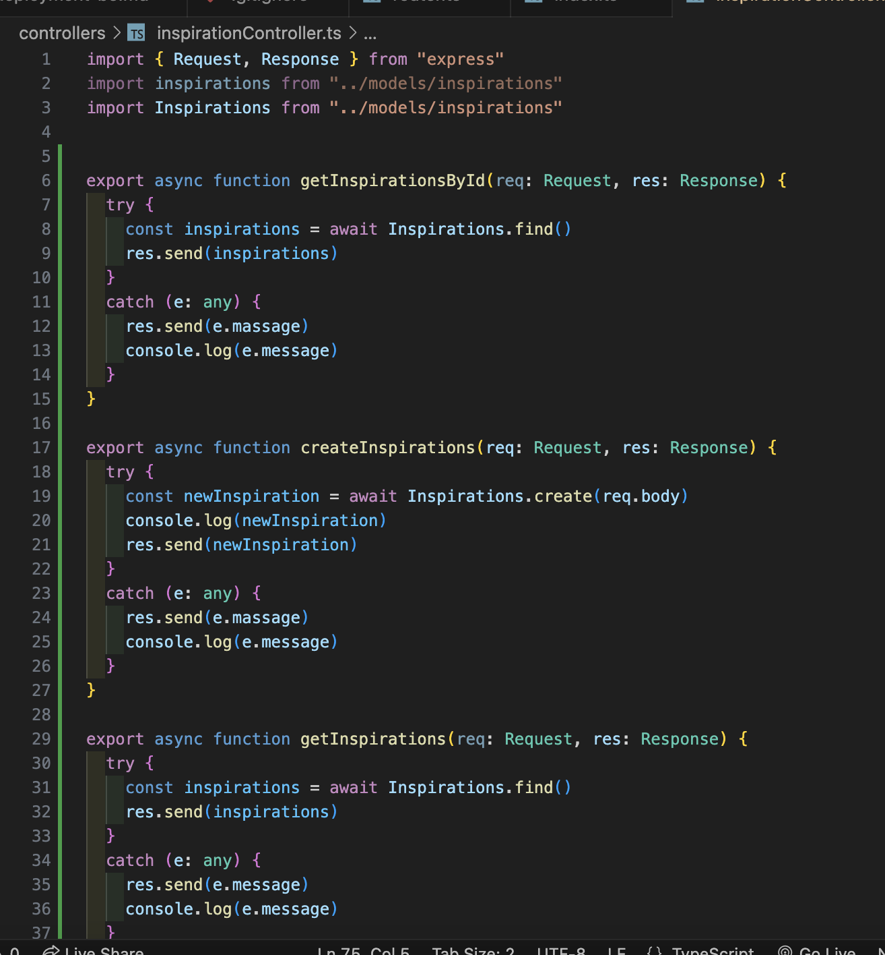

I created the InspirationsList where we can find all the inspirations posted from any user, get inspired from them and create our own ones with the food we have in the fridge which brings us to the original idea of why we decided to build this app.

I used React Hooks, in this case, .useState() to get inspirations, destructure, and update them later into inspirations cards with values shown in the interface. I did this by first sending a request using React promises, and getting back the data; I used .map() and .filter() methods to filter through the inspirations array and displayed the cards.

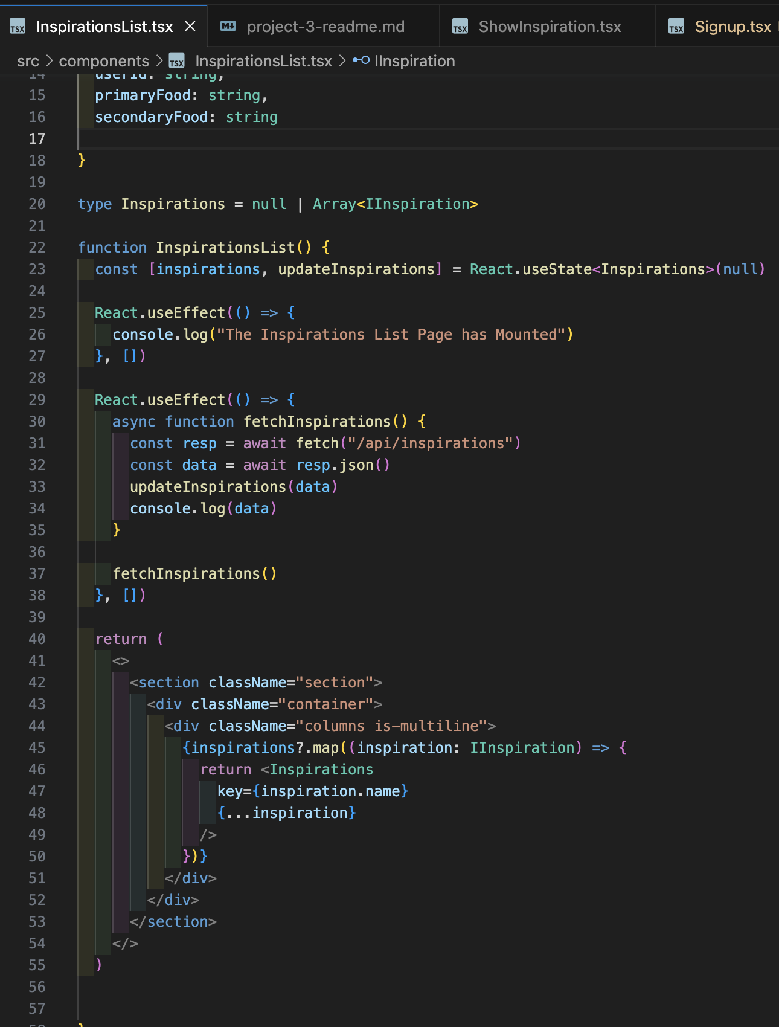

**Challenges**

*Challenges are great for showing your learning journey and problem solving, and this is a section that many engineers will check out. Every day of your engineering career you’ll encounter challenges, this is part of your growth and development. It’s the challenges you encounter that helps you become a stronger and more competent engineer.*

*Here you will detail any particular challenges you encountered as you were coding the project.*

*Questions to answer here:*

* *What technical challenges did you come across?*
* *Why were these challenges?*
* *What problem solving did you do to rectify them?*
* *Team dynamics/ Project management*
* *Tools/Tech you used*

**Insert your Challenges here:**

This was my first time working with Git as a member of a team so I had some problems with getting used to checking out and merging feature branches. Good communication was key to avoid major merge conflicts, and the encouraging team spirit kept our collective work to a high standard.

**Wins**

**Instructions**

*The Wins section is your opportunity to highlight the aspects of your project you are most proud of. See this as your chance to showcase these parts of your projects to the engineers reading your ReadMes.*

*Things you could discuss here:*

* *Interesting problem solving you did*
* *Strong sections of code*
* *Collaboration with other team members*
* *Visual design of the project*

**Insert your Wins here:**

Project 3 for me was a workspace where I could practise the code for building

signup and login pages which we’ve just learned during the course. I also learned to build the “upload Inspiration” form using React Axios library. The logic behind it was difficult but working in a team really helped me in this task. My whole understanding of backend, frontend, terminal and GitHub got much better during the development of this full-stack app.

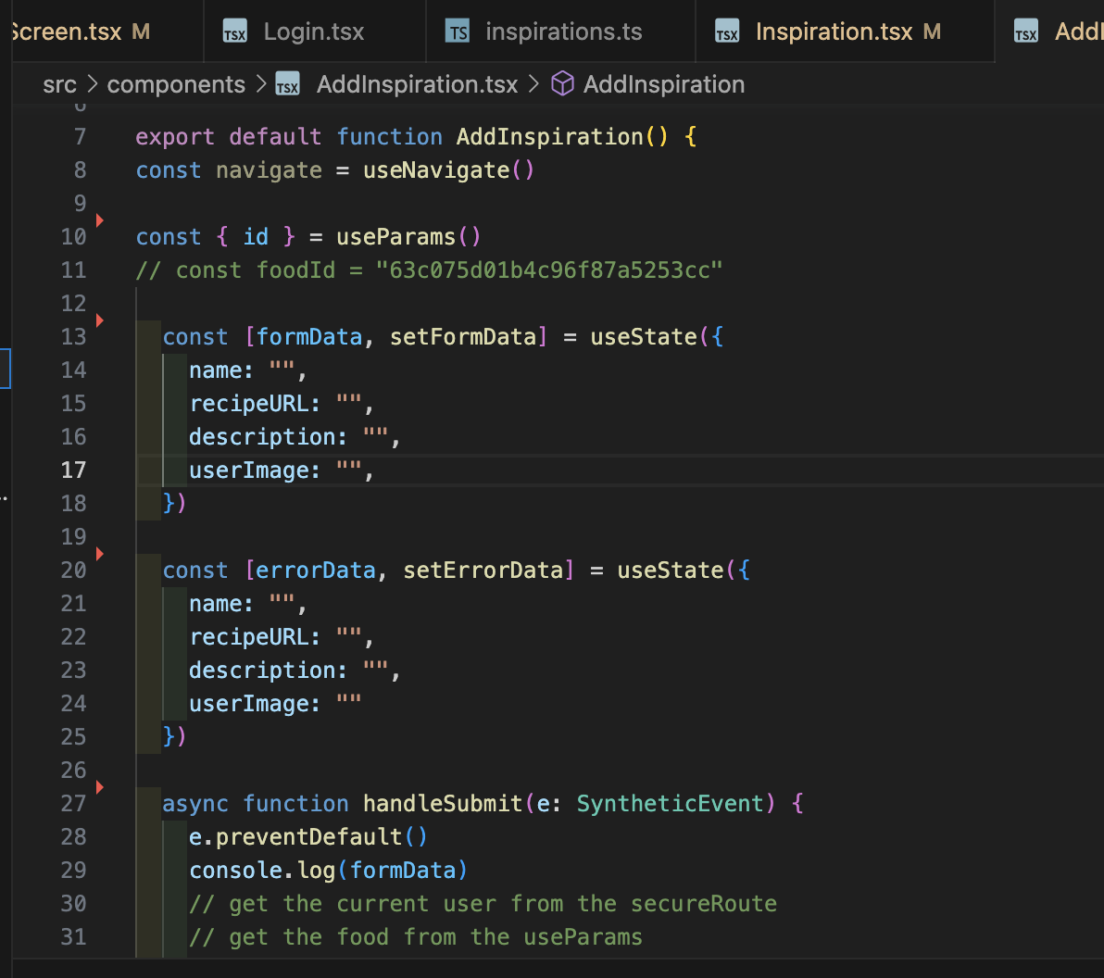

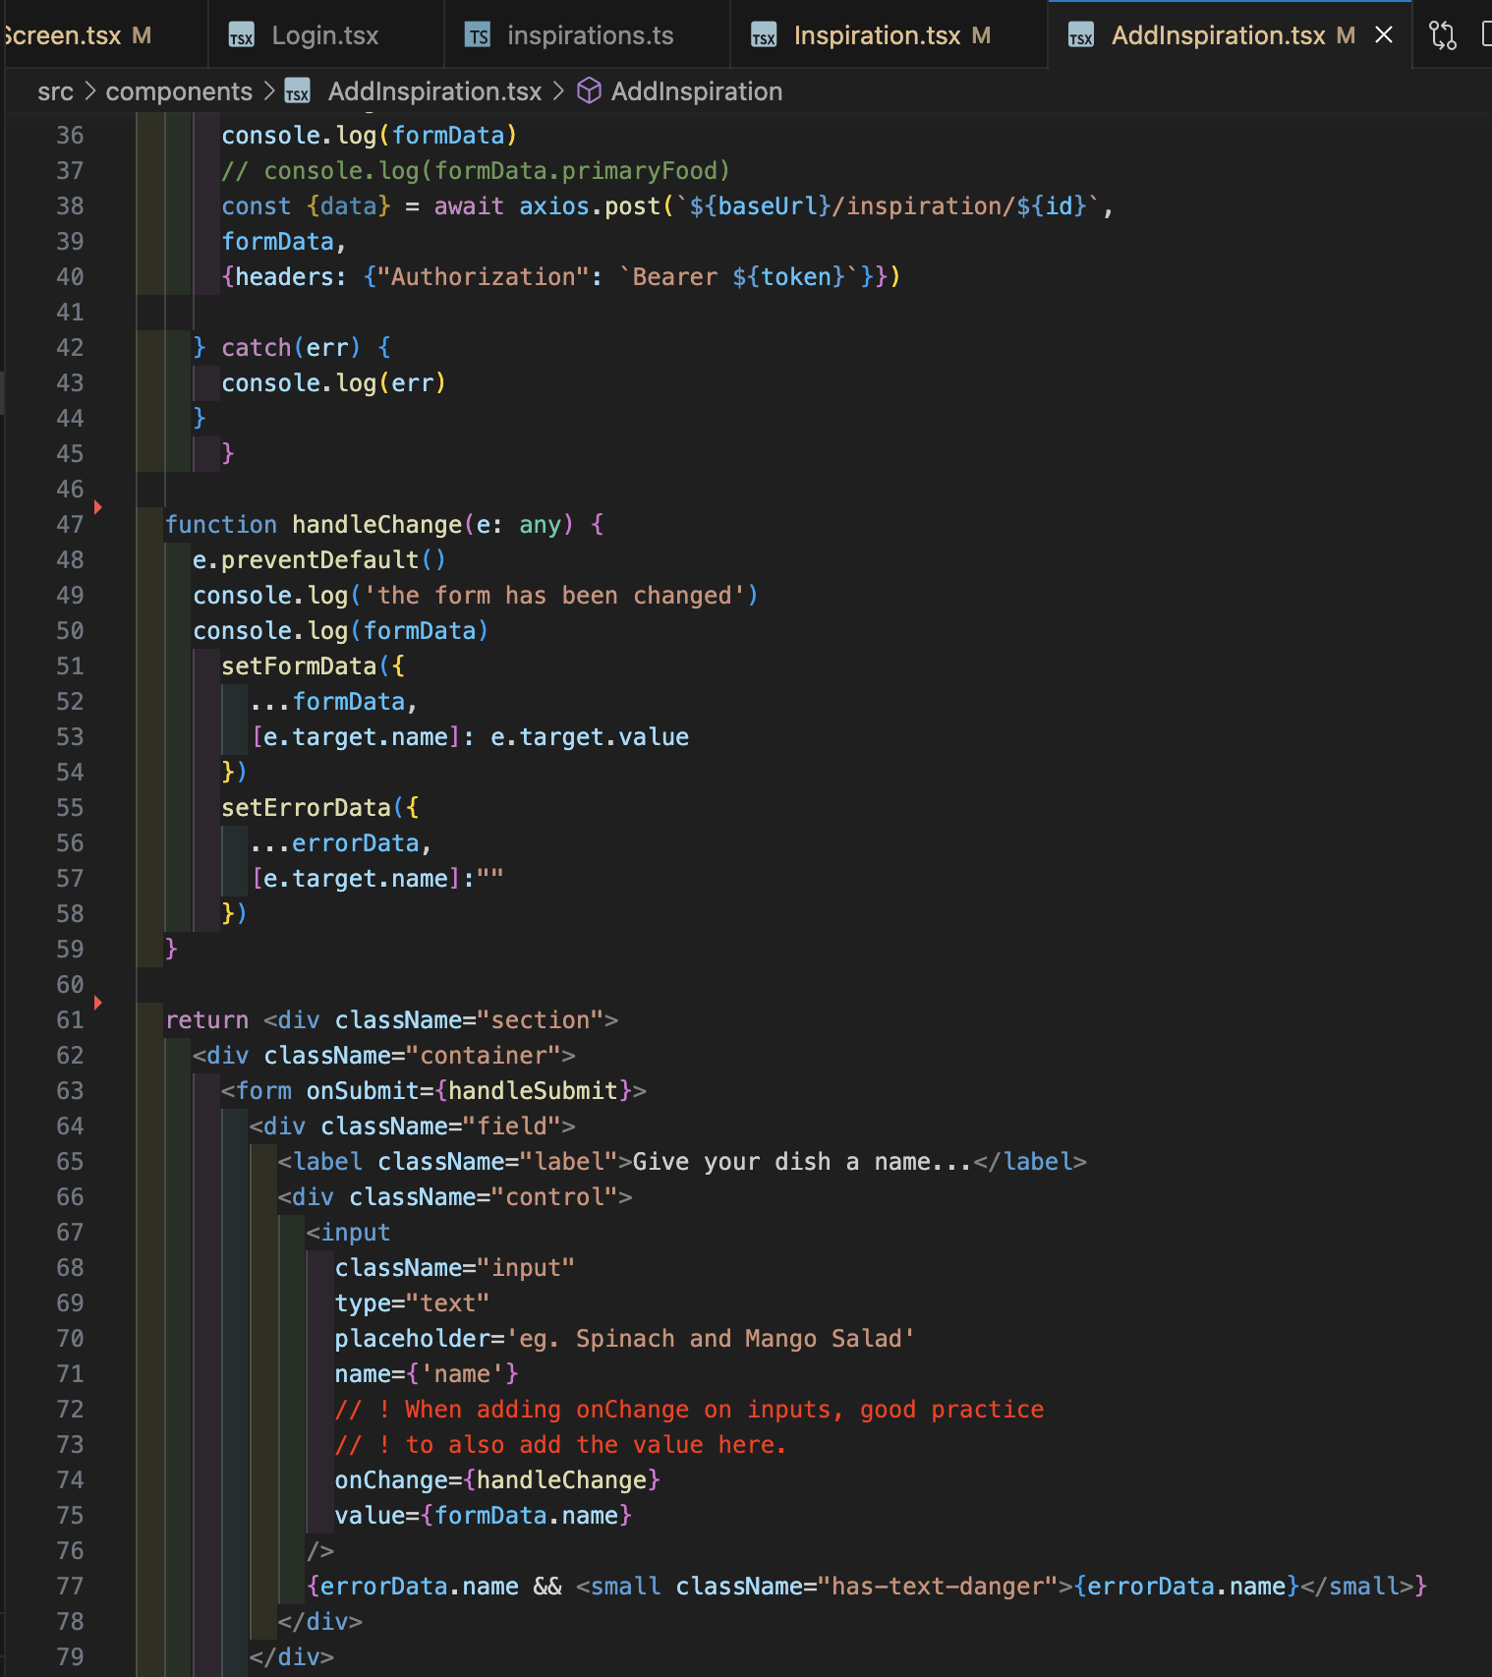

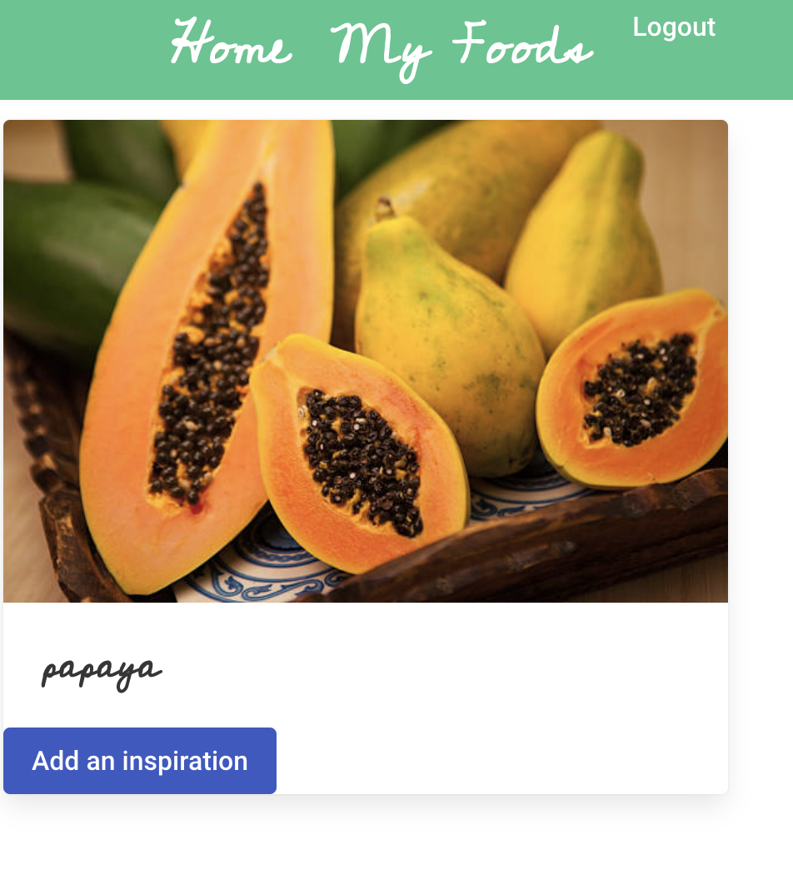

Here we are offered the button option to add an inspiration, which if clicked will direct us to the inspiration page

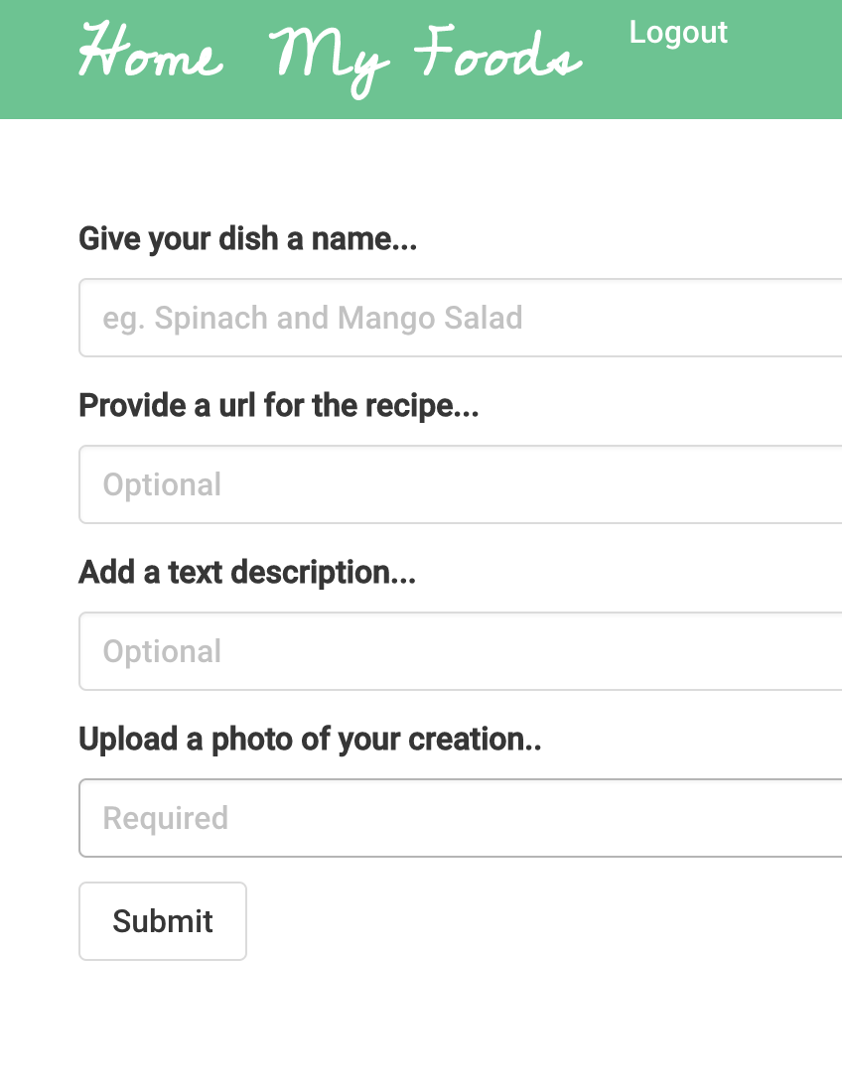

**Key Learnings/Takeaways**

**Instructions**

*This section is one of the other most important parts of your ReadMe from an engineers’ perspective and helps to differentiate each of you from your classmates and team members.*

*Engineers love to understand what you learn from each project and how it has shaped you as an engineer.*

*See this as your opportunity to show the engineers how your skills grew during each project sprint.*

*Things you could discuss here:*

* *What Technologies/Tools do you now feel more confident with? Tell them specifically what you learnt about these.*
* *What engineering processes did you become more comfortable with? Standups? Pair programming? Project management? Tell them what you learnt from these processes?*

**Insert your Key Learnings/Takeaways here:**

This project was definitely the most challenging up to date, bringing together everything we'd learnt on the course so far. Having each team member taking ownership of their respective area of responsibility, I came to realise the importance of a managing entity in a development team, i.e. to have someone leading the process and holding all the strings.

I found working as a part of a team very beneficial, collaborative work seemed to amp up my delivery and code quality to a whole other level.

**Bugs**

**Instructions**

*If you have any bugs in your project, it’s important that you flag them in your ReadMe. This helps the engineers reviewing your projects to understand that you are aware that there are issues - if you don’t flag these, then they won’t have that visibility that you know these problems are in your code and it can result in them not having a full understanding of your technical knowledge.*

*In either sentences or bullets, explain what the bugs are.*

*If you have no bugs, you can leave this section blank.*

**Insert your Bugs here:**

### There are no bugs so far.

**Future Improvements**

**Instructions**

*It’s common to get to the end of your project and have ideas on what you would do if you have more time, as well as how you might improve it.*

*If you do, you should detail this here. It’s great to give that context on potential future improvements, to share your creative or technical ideas with the engineers reading your ReadMes.*

*In either sentences or bullets, explain what your future improvements would be.*

**Insert your Future Improvements here:**

I would like more social features to the app in the future, like adding a chat option in order to make the users communicate with each other and feel more connected within the community.

I would like to apply some other styling features as well since we ran out of time and couldn’t add everything as planned.